**Flight Fare Prediction Web Application**

Domain Name: Aviation

Md Mojammil

Date: 30th May 2024

**Abstract :**

The objective of this project is to develop a machine learning model applcation for predicting flight fares. Accurate prediction of flight fares is crucial for airlines, travel agencies, and passengers to optimize pricing strategies, manage budgets, and make informed purchasing decisions. This project leverages a dataset containing various features such as departure and arrival times, airline, class, duration, days until departure, and other relevant factors influencing flight prices. By employing a combination of data preprocessing techniques and machine learning algorithms, including regression and ensemble methods, the model aims to predict flight fares with high accuracy. The performance of the model is evaluated using metrics such as Mean Absolute Error (MAE) and Root Mean Squared Error (RMSE). The results demonstrate the effectiveness of machine learning in capturing complex patterns within the data, providing reliable fare predictions, and highlighting significant features that impact pricing. This work contributes to the advancement of dynamic pricing models in the airline industry and offers valuable insights for future research and applications in travel fare prediction.

**Problem Statement :**

Travelling through flights has become an integral part of today’s lifestyle as more and more people are opting for faster travelling options. The flight ticket prices increase or decrease every now and then depending on various factors like timing of the flights, destination, and duration of flights various occasions such as vacations or festive season. Therefore, having some basic idea of the flight fares before planning the trip will surely help many people save money and time. The main goal is to predict the fares of the flights based on different factors available in the provided dataset.

**Customer Needs Assessment :**

There has been a significant increase in air travel, making the aviation sector a critical focus for fare prediction models. Our aim is to develop a flight fare prediction algorithm that will aid individuals, airlines, and travel agencies in understanding and anticipating fare fluctuations. This will help them make informed decisions and optimize their pricing strategies.

The proposed system uses a comprehensive dataset, including features such as departure and arrival times, airline, class, flight duration, and days until departure. This allows the machine learning model to make precise fare predictions, offering significant benefits to users.

The proposed system uses a comprehensive dataset, including features such as departure and arrival times, airline, class, flight duration, and days until departure. This allows the machine learning model to make precise fare predictions, offering significant benefits to users.

**Target Specification and Characterization :**

The goal of our flight fare prediction project is to provide precise and actionable insights into airfare trends, helping travelers make informed decisions about their journeys. The machine learning algorithm developed in this project can analyze various flight routes and predict fare prices, allowing for optimized route selection based on cost efficiency.

If multiple routes are available for a particular destination, our algorithm can determine the optimal route by comparing predicted prices. The route with the lowest predicted fare will be recommended, ensuring that travelers can choose the most cost-effective option.

Price prediction aids individuals in planning their trips more effectively, enabling them to maximize their travel potential within a given budget. By understanding fare trends and fluctuations, users can decide the best times to book flights and how to allocate their travel budget efficiently.

Additionally, gaining insights into flight prices can help travelers predict how far they can travel within a specific budget, allowing for better financial planning and enhancing the overall travel experience.

**External Search (Information Sources)**

The dataset for this project can be found on Kaggle under the title "Flight Fare Prediction MH" [link](https://www.kaggle.com/datasets/nikhilmittal/flight-fare-prediction-mh). This dataset includes comprehensive information pertinent to flight fare predictions, such as:

* The distance between the initial and final destinations
* The airline operating the flight
* The date and time of travel
* The duration of the flight
* Additional relevant features like the number of stops and cabin class

This dataset provides a robust foundation for developing a machine learning model to predict flight fares accurately. It allows for detailed analysis and feature engineering to identify the key factors influencing fare prices.

**Information Sources :**

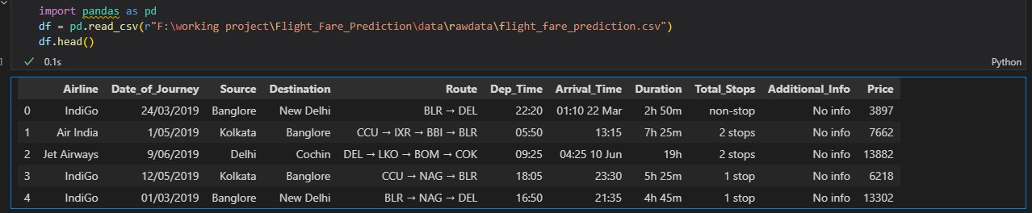

* Entities: Airline, Date of Journey, Source, Destination, Route, Departure and Arrival Times, Duration, Total Stops, Additional Info, Price
* Purpose: This dataset is the primary source for training the machine learning model, offering extensive data on various attributes that affect flight fares.

These datasets collectively enable the creation of a robust flight fare prediction model, capable of delivering precise fare estimates and helping travelers make informed decisions.

**Benchmarking :**

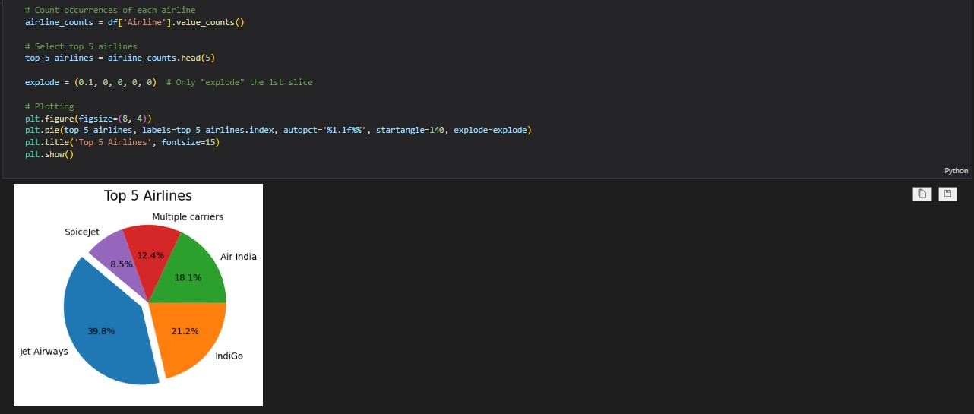

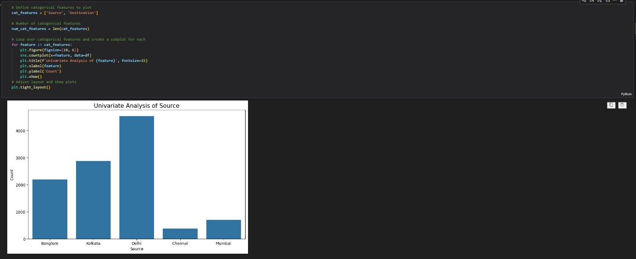

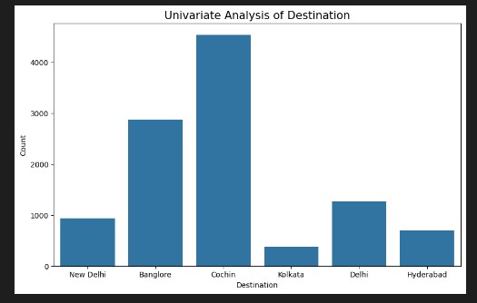

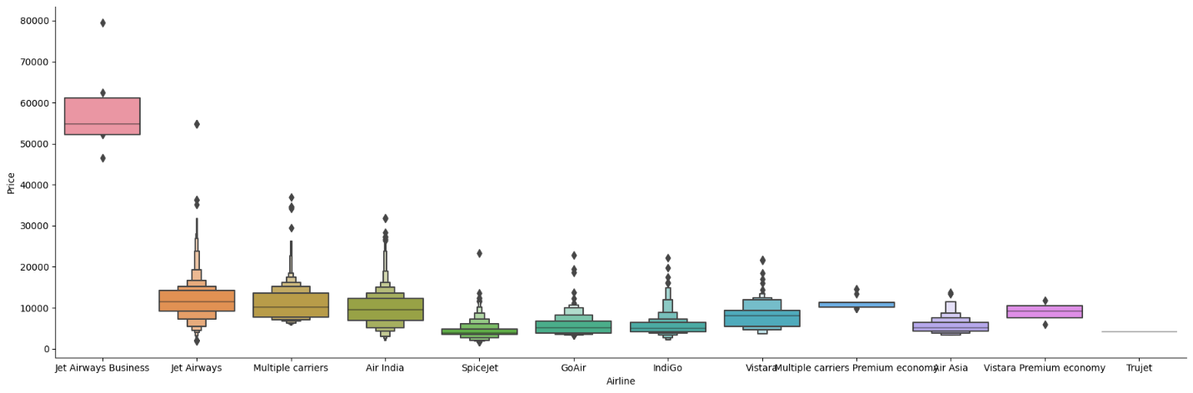

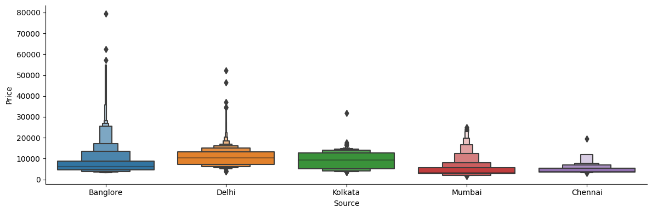

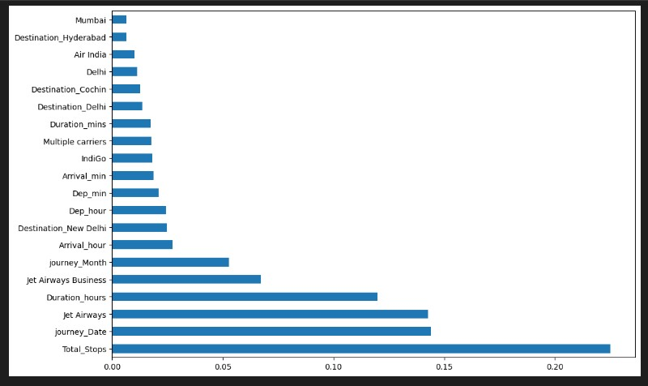

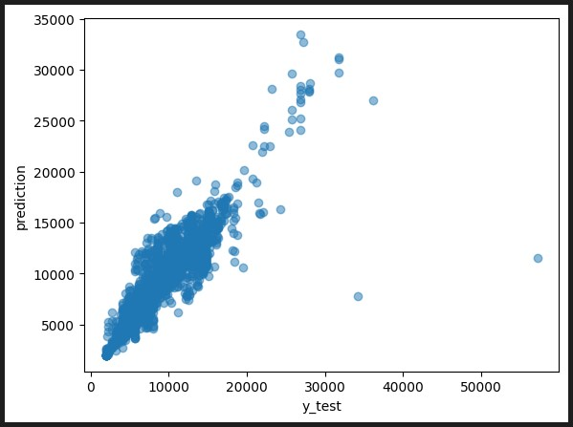

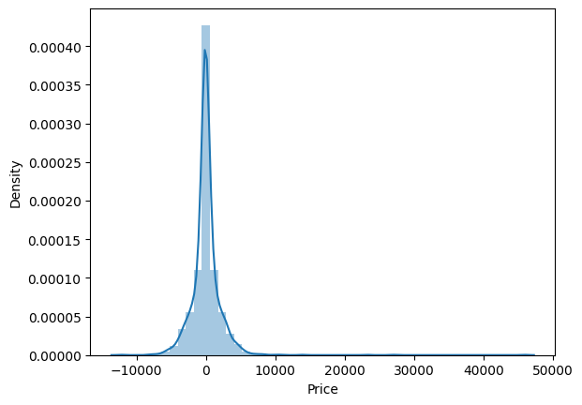

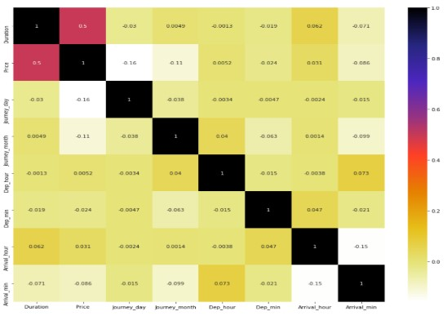

By utilizing these visualizations, we can gain valuable insights into the factors affecting flight fares, allowing for the development of a more accurate and robust prediction model. Understanding the interplay between these parameters helps identify key influences on pricing and optimize fare prediction algorithms accordingly.

**Applicable Patents:**

In the development of a flight fare prediction model, it is crucial to be aware of existing patents in the field. These patents may cover various aspects of fare prediction technology, including algorithms, data processing methods, user interfaces, and systems for dynamic pricing. Below are some key patents relevant to flight fare prediction and their potential impact on the project.

**US Patent 6,321,204 B1: System and Method for Determining the Price of Travel Services**

* Summary: This patent describes a system and method for determining the price of travel services, such as airline tickets, by using historical data, current booking data, and other relevant information to predict fare prices.
* Key Features: Data aggregation from multiple sources, fare prediction algorithms, dynamic pricing adjustments.
* The methodology and exploratory data analysis (EDA) used in this project may draw inspiration from established research and patents in the field. For instance, the techniques discussed in the International Journal of Interdisciplinary Innovative Research & Development (IJIIRD) could be valuable.

International Journal of Interdisciplinary Innovative Research & Development (IJIIRD)

ISSN: 2456-236X

Vol. 05 Issue 01 | 2020

The current patent may incorporate this patent for the inspiration of the methodology used as well as EDA analysis to some extent.

**Applicable Regulations:**

* Ensure algorithms are developed and optimized individually to avoid patent claims.
* Avoid using pre-existing models that may incur patent claims.
* Provide access to third-party websites to audit and monitor the authenticity and behavior of the service.
* Comply with policies against collecting customer data from websites, including reviews and ratings.
* Ensure data collection methods adhere to GDPR, CCPA, and other relevant data protection regulations.
* Anonymize personal data to protect individual privacy.
* Securely handle and protect the scraped data, respecting the privacy and original context of the data.

**Applicable Constraints:**

* Limited access to high-quality, comprehensive datasets may constrain the accuracy of the model.
* Incomplete or noisy data can affect model training and prediction reliability.
* Must comply with GDPR, CCPA, and other data protection laws, which may limit the use of certain data and require specific data handling procedures.
* Adherence to airline industry standards and regulations, such as those from IATA, is necessary.
* Ensuring user privacy and ethical use of data is crucial.
* Developing, maintaining, and scaling the model involves significant costs.

**Business Opportunity:**

The development of a flight fare prediction model presents significant business opportunities in the travel and aviation industry. By leveraging advanced machine learning algorithms and data analysis techniques, this model offers substantial value to various stakeholders, including airlines, travel agencies, consumers, online travel platforms, and corporate clients.

**Key Benefits:**

* Optimized pricing strategies, enhanced revenue management, and increased customer loyalty.
* Competitive advantage, improved customer satisfaction, and operational efficiency.
* Cost savings, informed decision-making, and reduced travel stress.
* Increased user engagement, higher traffic, and better conversion rates.
* Improved budget management and effective travel planning.

**Concept Generation:**

In developing the flight fare prediction system, the choice of machine learning models is critical to meet our unique requirements. While building models from scratch may seem daunting, tweaking existing models such as the Random Forest Regressor offers a feasible approach. Here's an overview of the concept generation process and feasibility screening, with a focus on utilizing the Random Forest Regressor:

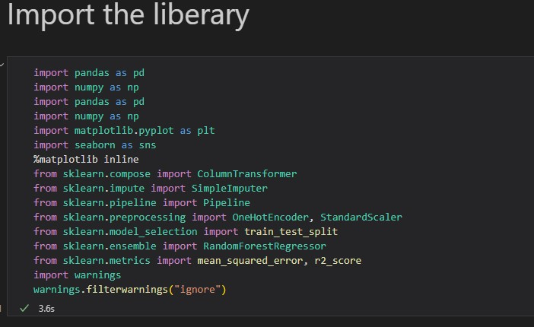

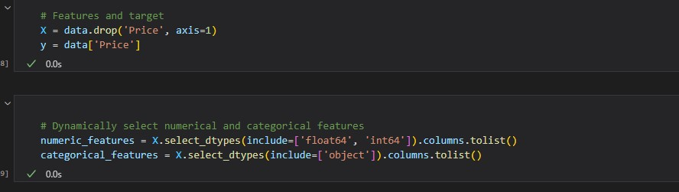

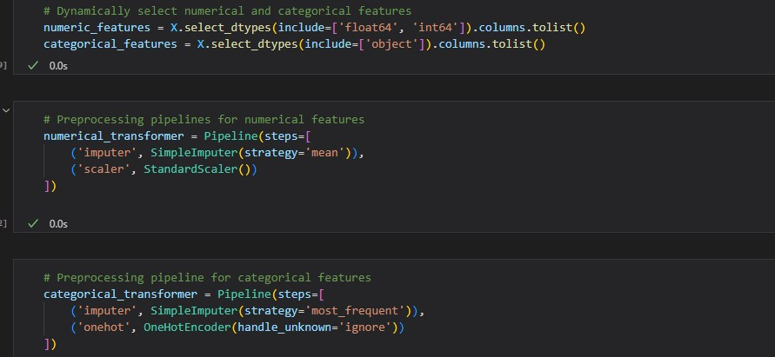

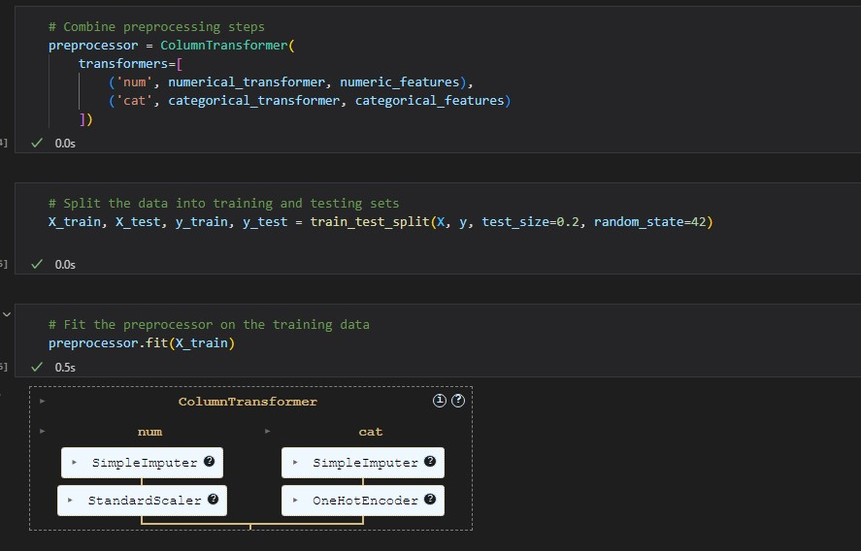

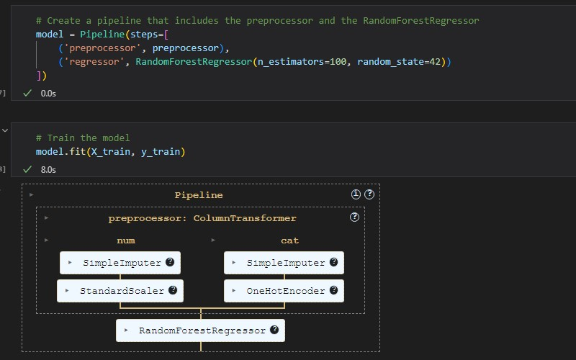

**The Accuracy of the initial model is given below:**

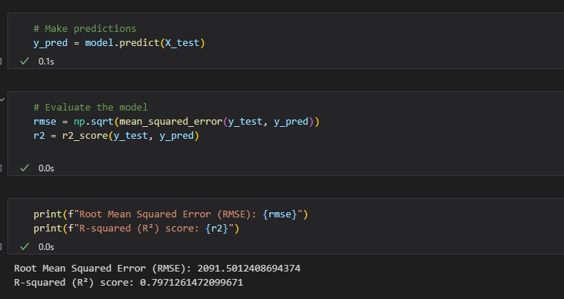

**Concept Development :**

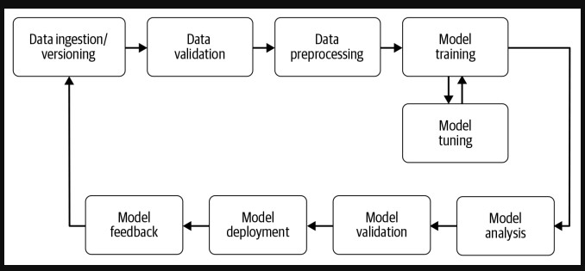

**Final Report Prototype:**

The flight fare prediction application aims to provide accurate and user-friendly fare predictions by leveraging advanced machine learning techniques. To achieve optimal results, the product development involves both back-end and front-end functions. Here's a detailed outline:

* **Back-End Development:**

**Model Development :** Before releasing the service, extensive manual supervised machine learning is necessary to optimize the automated prediction tasks.

1. **Exploratory Data Analysis (EDA):**

* Conduct EDA to identify and understand the dependent and independent features in the dataset, such as airline, date of journey, source, destination, route, departure and arrival times, duration, total stops, additional information, and price.

1. **Algorithm Training and Optimization:**

* Train the Random Forest Regressor algorithm to predict flight fares accurately.
* Perform hyperparameter tuning to minimize overfitting and enhance the model’s generalizability and performance.
* **Front-End Development:**

1. **User Interface Design:**

* Provide users with multiple options to select parameters relevant to their travel plans (e.g., departure date, destination, airline, etc.).
* Continuously optimize the interface through extensive testing and analysis of various edge cases to ensure it meets user needs and preferences.

1. **Interactive Visualization:**

* Present the data extracted from the trained models in a visually appealing and easy-to-understand format.
* Utilize interactive visualizations such as scatterplots, box plots, and bar charts to help users interpret fare predictions and understand pricing trends.

1. **Feedback System:**

* Develop a robust feedback system to capture user input and identify unmet needs.
* Utilize interactive visualizations such as scatterplots, box plots, and bar charts to help users interpret fare predictions and understand pricing trends.

**Prototype Project github link:**

**Link :** https://github.com/mohdmojammil3/Flight_Fare_Prediction.git

**Prototype Web Application**

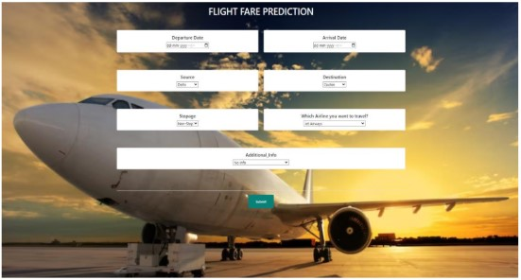

**Product details - How does it work?**

The flight fare prediction application operates through a seamless interaction between the user and the underlying machine learning model. Here’s a step-by-step breakdown of how the application works:

1. **Interactive User Input System:**

**User Interface (UI):** The application features a user-friendly interface where users can

input details. Which includes

* Date of journey.
* Preferred airline.
* Class of travel (e.g., economy, business).
* Number of stops (direct or with stopovers).
* Additional preferences (e.g., meal options, baggage).

1. **Real-Time Data Processing:**

**Dynamic Data Integration:** The application integrates real-time data sources, including

* Current weather conditions.
* Recent fare trends.
* Availability and demand for flights.

**User Input Validation:** The input provided by the user is validated to ensure all necessary information is complete and accurate**.**

1. **Machine Learning Model Execution:**

* **Feature Processing:** The application processes the user inputs and transforms them into features compatible with the machine learning model.
* **Prediction Engine:** Using the trained Random Forest Regressor, the application analyzes the input features and predicts the flight fare.

**Summary:**

The flight fare prediction application offers a highly interactive and user-centric experience. By leveraging advanced machine learning models and real-time data integration, users receive immediate and accurate fare predictions tailored to their specific journey details. The intuitive interface and continuous feedback loop ensure the application remains effective, adaptable, and user-friendly.

**Business Model for Flight Fare Prediction Application**

**Overview**

The Flight Fare Prediction application leverages advanced algorithms and real-time data to predict future airfare prices, enabling users to book flights at the most cost-effective times. Our business model focuses on multiple revenue streams, ensuring profitability and sustainability. This model includes freemium services, subscription plans, affiliate marketing, data monetization, and advertising.

**Revenue Streams**

**Freemium Model**

**Free Tier**: Provides basic fare prediction for limited routes and dates. Users get a taste of the app's capabilities, which encourages them to upgrade to the premium version.

**Premium Tier**: Offers comprehensive features, including detailed fare predictions, personalized alerts, historical fare data, and broader route and date access. Users can subscribe to monthly or annual plans.

**Subscription Plans**

**Monthly Subscription**: Users pay a recurring monthly fee to access premium features. This plan appeals to occasional travelers who need the service for a limited period.

**Annual Subscription**: Users pay a yearly fee at a discounted rate compared to the monthly plan, ideal for frequent travelers. This plan ensures higher upfront revenue and customer retention.

**Affiliate Marketing**

Flight Bookings: Partner with airlines and travel agencies to receive a commission for each flight booked through our app. When users find a predicted fare that suits them, they are redirected to our partners to complete the purchase.

Travel Insurance and Services: Collaborate with travel insurance companies and other travel-related service providers, earning a commission on each sale generated through our app.

**Data Monetization**

Market Insights Reports: Sell anonymized and aggregated data insights to airlines, travel agencies, and market research firms. These reports provide valuable information on consumer behavior, fare trends, and market demand.

API Access: Offer API access to third-party developers and businesses interested in integrating our fare prediction technology into their platforms for a fee.

**Advertising**

In-App Advertisements: Display targeted ads within the free version of the app. Ads can include travel-related products and services, generating revenue through impressions and clicks.

Sponsored Listings: Allow airlines and travel companies to pay for prominent placement within the app, increasing their visibility to users actively searching for flights.

**Monetization Strategy**

**User Acquisition and Engagement**

Utilize a combination of digital marketing strategies, including SEO, content marketing, social media campaigns, and partnerships with travel bloggers and influencers to attract users.

Implement referral programs encouraging existing users to invite friends, rewarding both parties with discounts or free premium access.

**Conversion Optimization**

Offer limited-time discounts or free trials of premium features to convert free-tier users to paying subscribers.

Utilize in-app messaging and email campaigns to highlight the benefits of premium features, particularly during peak travel seasons.

**Retention and Upsell**

Provide exceptional customer support and regular updates to ensure user satisfaction.

Continuously introduce new features and enhancements to maintain user interest and justify subscription costs.

Offer loyalty rewards or exclusive deals for long-term subscribers.

**Partnership and Expansion**

Expand partnerships with more airlines, travel agencies, and service providers to increase affiliate marketing revenue.

Explore international markets and tailor the app to cater to different regions, considering local travel behaviors and preferences.

**Financial Projections**

**Year 1:** Focus on user acquisition and market penetration. Expect modest revenue from subscriptions and affiliate marketing.

**Year 2:** Significant growth in subscription revenue as user base increases. Begin data monetization and expand advertising efforts.

**Year 3:** Stabilized revenue streams with a mature user base. Higher profits from API access and comprehensive market insights reports. Continued growth from international expansion and new partnerships.

**Conclusion**

The Flight Fare Prediction application aims to revolutionize how consumers book flights by providing accurate fare predictions and valuable travel insights. Through a well-rounded business model encompassing freemium services, subscriptions, affiliate marketing, data monetization, and advertising, we ensure diverse and sustainable revenue streams. This strategy not only maximizes profitability but also offers exceptional value to our users, fostering long-term growth and success.

**References/Source of Information:**

**Dataset Source:**

* <https://www.kaggle.com/datasets/nikhilmittal/flight-fare-prediction-mh>

**Machine Learning Algorithms:**

* <https://link.springer.com/article/10.1023/A:1010933404324>

**Exploratory Data Analysis (EDA):**

* <https://pandas.pydata.org/docs/index.html>

**Scikit-Learn Documentation:**

* https://scikit-learn.org/stable/

**Applicable Regulations and Privacy:**

* <https://gdpr.eu/>